**E-commerce Web Application using Jenkins Pipeline ,docker**

**Project structure**

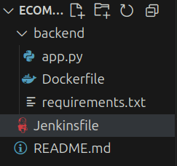

**backend/app.py**

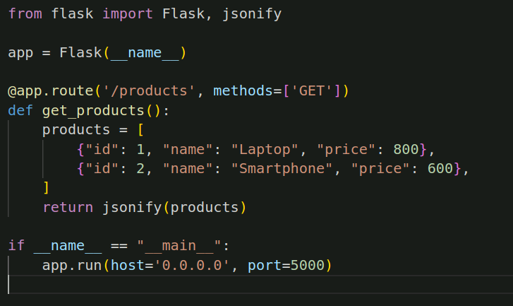

**Backend/Dockerfile**

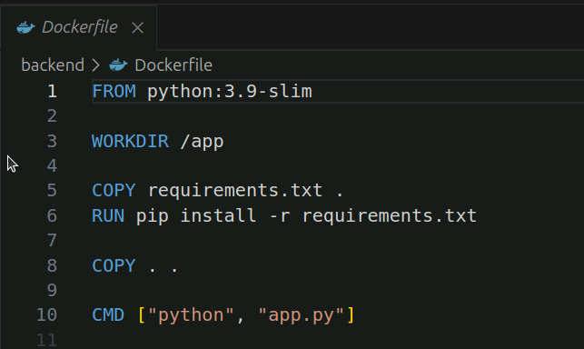

**Create the Jenkins code for Ecommerce website.**

**Set Up Jenkins Job**

**1. Create a Jenkins Job:**

Go to Jenkins Dashboard → New Item → Pipeline.

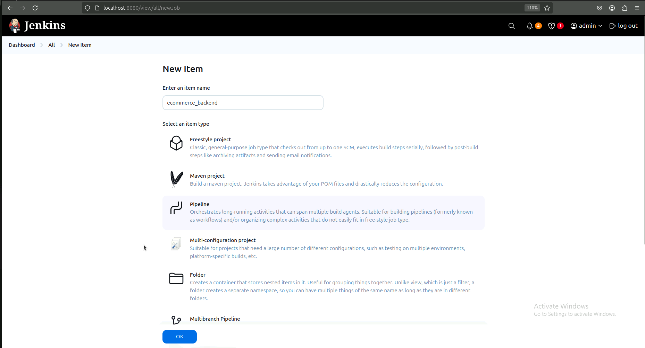

**2. Source Code Management:**

Choose Git → Provide Repository URL.

**3. Pipeline Definition:**

Select Pipeline script from SCM.

Choose Jenkinsfile from the repository.

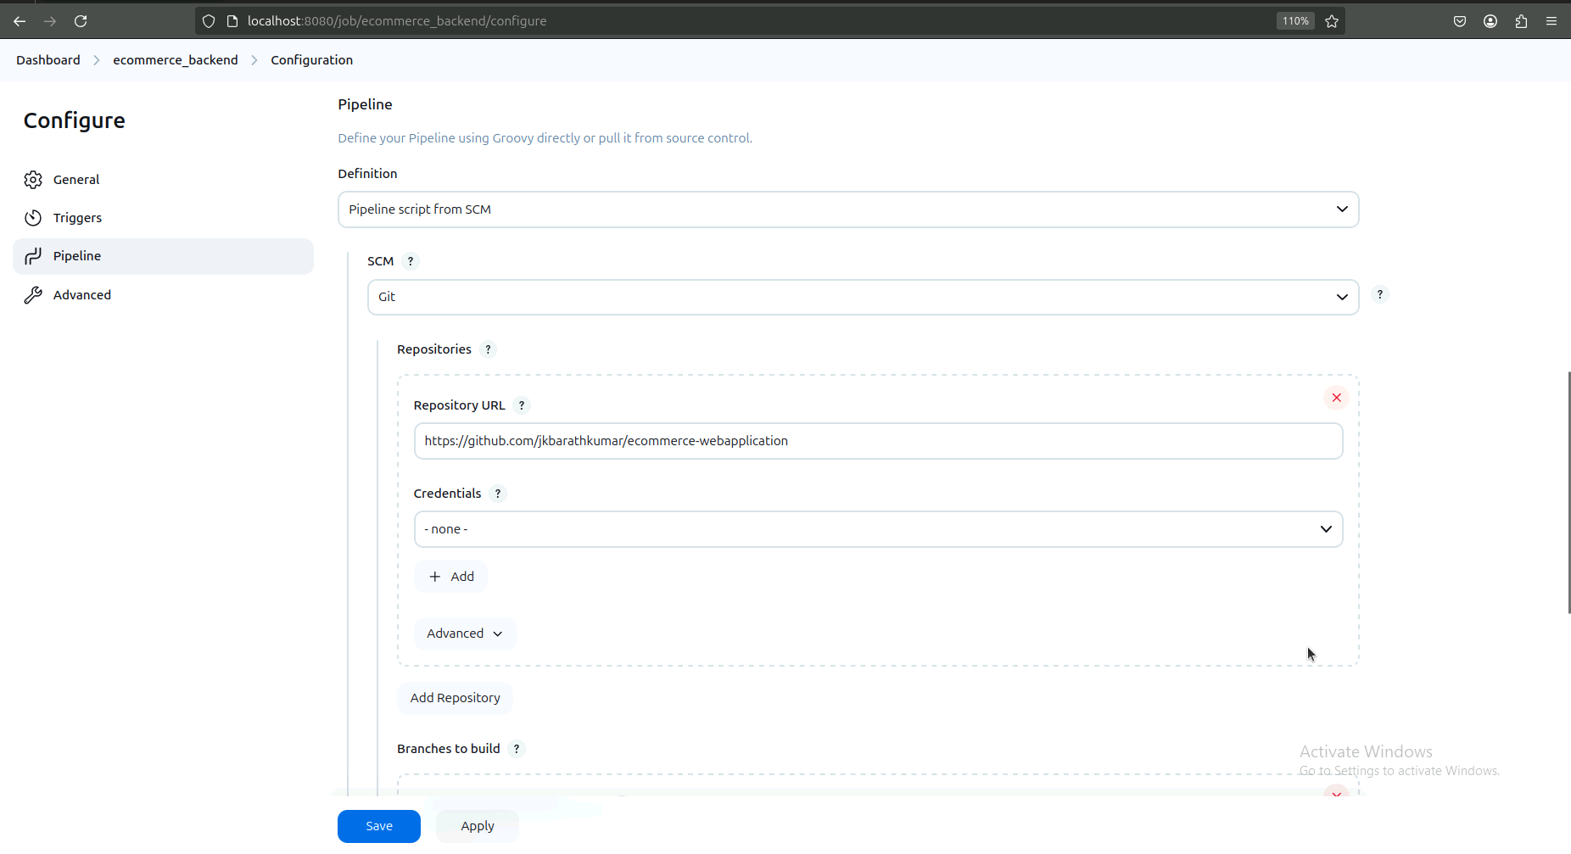

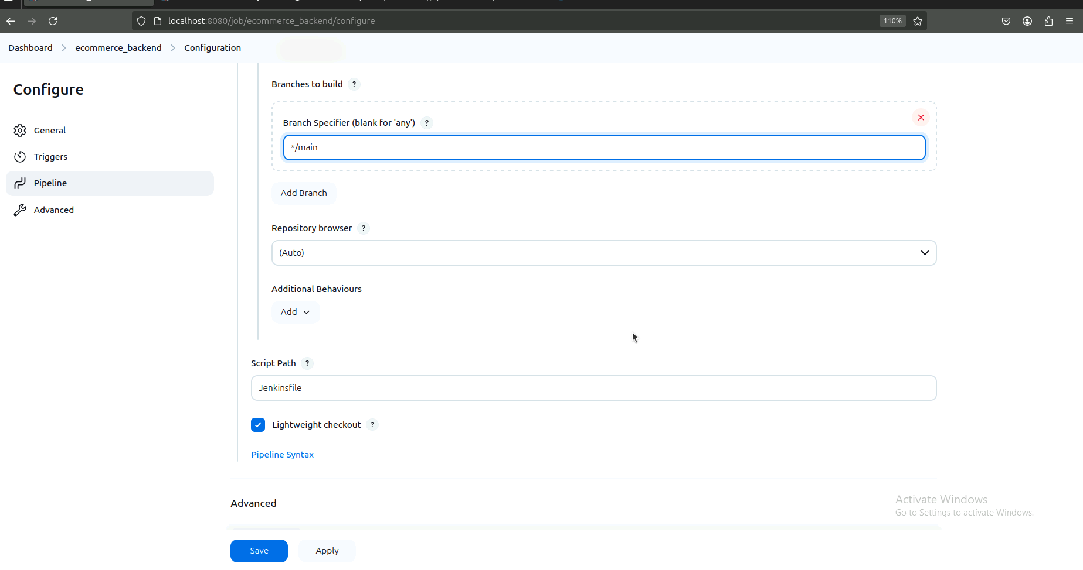

**4. Add Docker Credentials:**

Go to Jenkins → Manage Jenkins → Manage Credentials.

Add Docker Hub credentials with ID dockerhub-credentials.

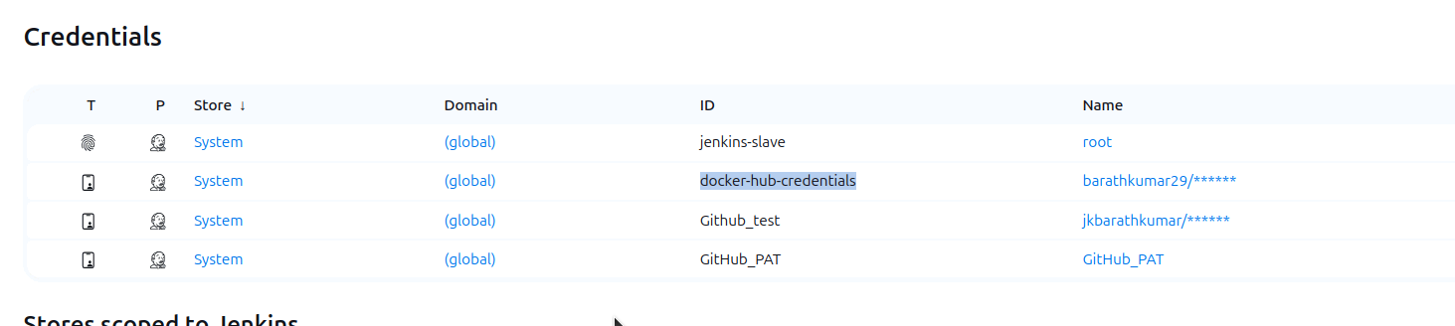

**1) Write the Jenkinsfile that implements this pipeline, adhering to the specified stages and post-build conditions.Your goal is to create a Jenkins pipeline code in groove script with the following requirements:**

1. Environment Setup:

Define environment variables:

DOCKER_IMAGE: The name of the Docker image should be my-ecommerce-backend.

DOCKER_TAG: Dynamically set to the Jenkins build number.

REGISTRY: The Docker Hub repository should be dockerhub_user/my-ecommerce.

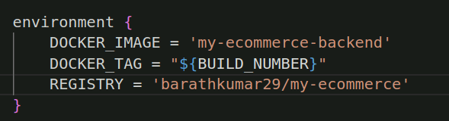

**2. Pipeline Stages:**

Checkout Code:

Clone the repository from GitHub: https://github.com/your-user/ecommerce-project.git.

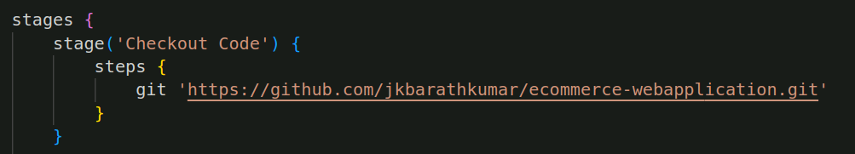

o Build Docker Image:

Inside the backend directory, build a Docker image tagged as ${DOCKER_IMAGE}:${DOCKER_TAG}.

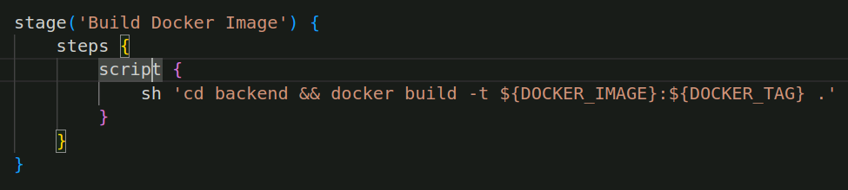

o Push to Docker Hub:

Push the built Docker image to Docker Hub using the Jenkins credentials ID: dockerhub-credentials.

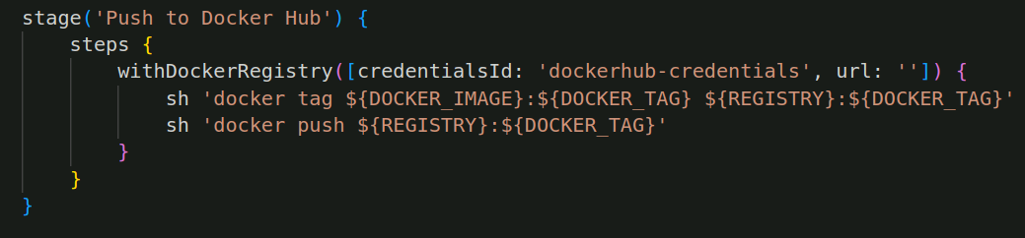

**o Deploy to Local Docker:**

Stop any running container named ecommerce, remove it if it exists, and run a new container.

The container should map port 5000 on the host to 5000 inside the container.

The new container should use the image ${DOCKER_IMAGE}:${DOCKER_TAG} and be named ecommerce.

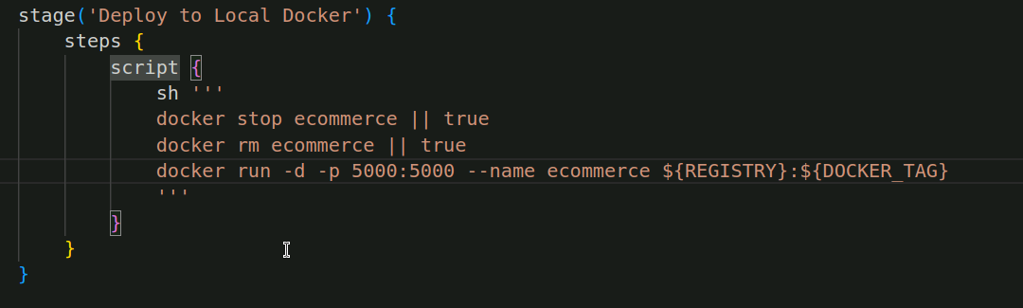

**3. Post-Build Actions:**

o On Success, print the message "✅ Deployment Successful!".

o On Failure, print the message "❌ Deployment Failed!"

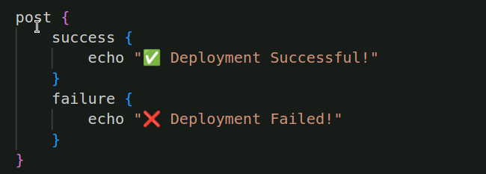

**Jenkins output:**

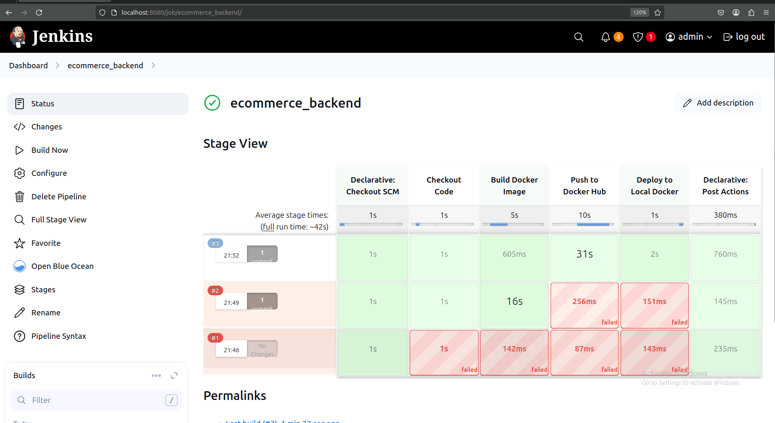

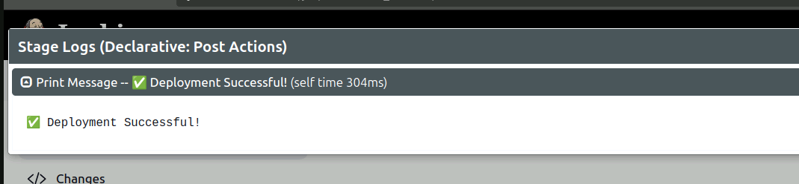

**To check the running container**

**· docker ps**

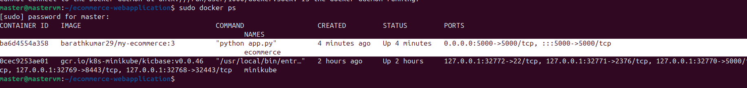

**Test the Application:**

**curl** [**http://localhost:5000/products**](http://localhost:5000/products)



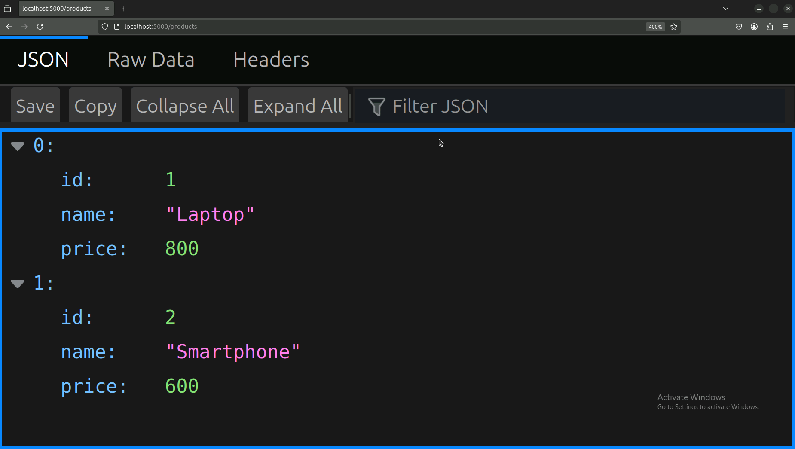

· After running the pipeline job, go to Jenkins Dashboard > Your Project > Last Build.

· Click on Console Output.

· A successful pipeline should display messages like:

Deployment Successful!

Finished: SUCCESS

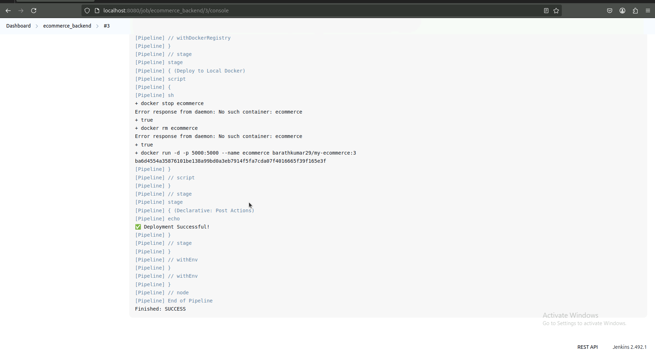

**Final outputs:**

Build Success:



Dockerhub:

